Objectives
Experiment (7)

Wide Area Network (WAN)



To achieve Encapsulation between 2 Routers

Equipment / Program Requirements:

ENSP

Experiment Setup:

Make topology as shown then make encapsulation then ping between 2 routers to check connections

Simulation Results:

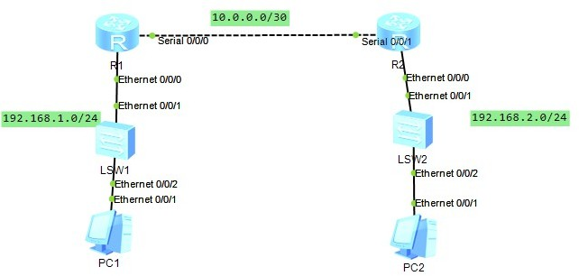

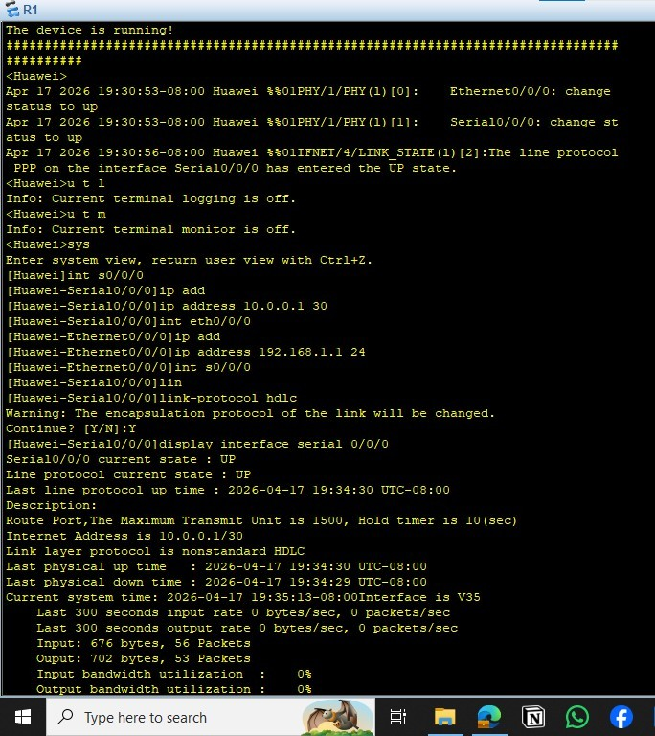

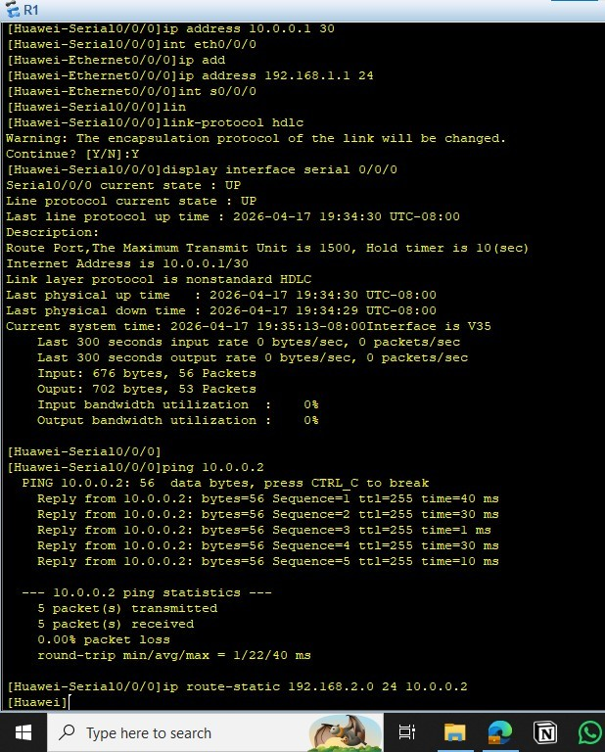

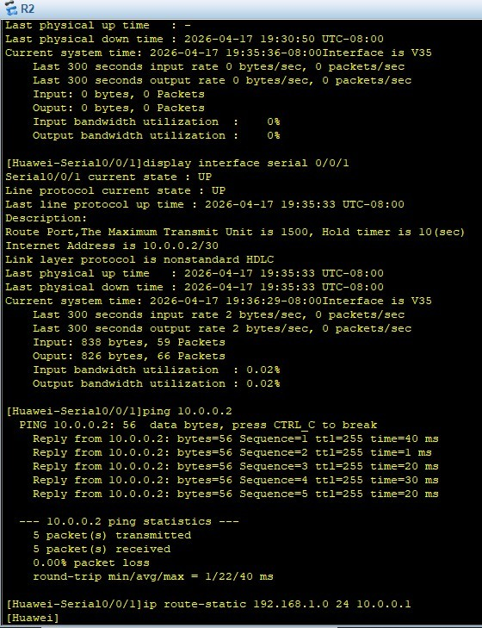

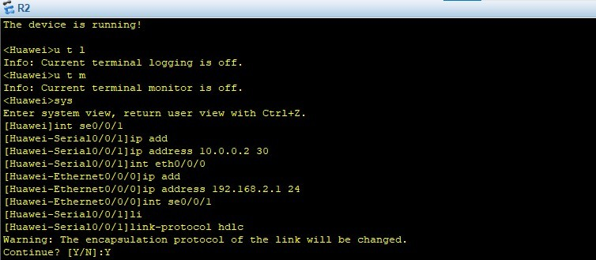
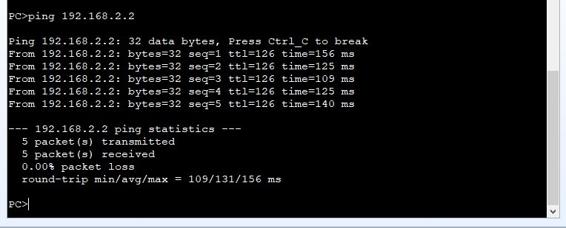

  - Conclusions:
Encapsulation Is important for 2 routers to move data between 2 routerss

